Importance of safe food

Contaminated and adulterated foods are major causes for several food-borne illnesses in the country
- Safe and good-quality foods are essential for maintaining good health
- Naturally-occurring toxins, environmental contaminants and adulterants in foods constitute a health hazard.
- Consumption of unsafe foods can lead to food-borne diseases.
- Buy food items from reliable sources after careful examination.
- Wash vegetables and fruits thoroughly before use.
- Store the raw and cooked foods properly and prevent microbial, rodent and insect invasion.
- Refrigerate perishable food items.
- Maintain good personal hygiene and keep the cooking and food storage areas clean and safe.
- Always use throughly cleaned utensils for cooking/ eating.

Microbes (bacteria and moulds) and their products are responsible for food spoilage. Natural enzymes present in food also lead to its deterioration. Besides, insects, rodents, adulterants, natural toxins and various chemical residues beyond permissible levels, make the food unwholesome. In addition to moisture and environmental conditions like temperature, storage time also influence the quality of the food.

Selection of safe food: Selection of the right food is the first step to ensure safe and good quality diet. Food items purchased from reliable sources having a high turnover ensure their freshness.
- Some foods carry certification mark assuring good quality. For example AGMARK for honey and ghee; FPO (Fruit Products Order) for fruit and vegetable products (jams, squashes, etc); ISI (Bureau of Indian Standards) for food colours and essences. While purchasing packaged food look for ‘best before’ or ‘date of expiry’.
- Food grains purchased should be free from infestation and foreign matter (rodent excreta and insect remains). They should be of uniform size and should not be shrivelled, shrunken or mouldy.
- Foodstuffs should be free from artificial colors.
- There is a risk of adulteration when fats/oils are purchased loose from unsealed containers. Therefore, it is always safer to purchase reputed brand products in sealed sachets/containers.
- It is necessary to buy pasteurized milk in sachets from a reputed dairy or a reliable vendor to avoid the risk of adulteration and contamination. Milk products such as butter, ghee and khoa should also be purchased from reliable sources.
- Whole spices, uniform in color, size and shape should be preferred. Since powdered spices are more likely to be adulterated, always buy certified products.
- Fruits and vegetables that show patches, physical damage with bruises or wilted and decayed with visible evidence of insects and moulds, should be avoided.
- Eggs should be fresh and free from cracks.
- Meat or poultry must be examined for characteristic color, odor and texture and should be purchased fresh or frozen.
- Freshness of fresh-water fish is indicated by a stiff body, bright, clear and bulging eyes, reddish gills, tight scales and absence of stale odor or discoloration. Fresh fish will not show any pitting on finger pressure.

Adulteration of food
Foods may be adulterated with non-food material or inferior quality product. Spoilt, stale or poor quality food is made attractive and fresh by adding harmful colors or other chemicals. Frequently adulterated food items are milk and milk products, cereals, pulses and their products, edible oils and spices.
The different classes of adulterants include non-permitted colors like metanil yellow; non-edible oils like castor oil; cheaper agricultural produce like various starches in milk powder; extraneous matter like husk, sand and sawdust; and metal contaminants like aluminum or iron filings. Consumption of adulterated foods could lead to disease outbreaks of epidemic proportions. Buying from a reliable and reputed source, careful checking of foods before purchase and insisting on certified brands will all minimize the risk of food adulteration.

FOOD HAZARDS
PHYSICAL HAZARDS
Physical Hazards in Food Physical hazards are either foreign materials unintentionally introduced to food products (ex: metal fragments in ground meat) or naturally occurring objects (ex: bones in fish) that are hazardous to the consumer. A physical hazard contaminates a food product at any stage of production. Food processors should take adequate measures to avoid physical hazards in food.

Physical Hazards Risk in Food
• Hard or sharp objects are potential physical hazards and can cause:
– cuts to the mouth or throat
– damage to the intestines
– damage to teeth or gums
• The presence of physical hazards in food can trigger a food recall, affecting the brand name of your company and product.

Factors Determining a Potential Risk : Factors that cause potential risk to consumers in food products include:
• Size: Health Canada states that anything in a food product, that is extraneous, and measures two millimeters or more in size can be a health risk.
• Type of consumer: Products that target infants, the elderly, etc. have a higher risk level.
• Type of product: The form the product takes such as infant formulas, beverages, etc. can increase risk level.
• Physical characteristics: hardness, shape and sharpness of a product can affect risk level.

Common Physical Hazards Common sources of physical hazards in food include:
• Glass: light bulbs, glass containers and glass food containers
• Metal: fragments from equipment such as splinters, blades, needles, utensils, staples, etc.
• Plastics: material used for packaging, fragments of utensils used for cleaning equipment
• Stones: incorporated in field crops, such as peas and beans, during harvesting
• Wood: splinters from wood structures and wooden pallets used to store or transport ingredients or food products
• Natural components of food: hard or sharp parts of a food (ex: shells in nut products) if consumers do not expect them

Preventing Common Physical Hazards
There are many ways food processors can prevent physical hazards in food products. Assess every step of your operation for potential sources of contamination:

• Inspect raw materials and food ingredients for field contaminants, such as stones in cereals that were not found during receiving.
• Handle food according to Good Manufacturing Practices (GMPs). (Ex: avoid inclusion of physical hazards such as jewelry or false fingernails in food products by using proper personnel practices.)
• Eliminate potential sources of physical hazards in processing and storage areas. (Ex: use protective acrylic bulbs or lamp covers to prevent contamination by breakable glass.)
• Install an effective detection and elimination system for physical hazards. (Ex: metal detectors or magnets will detect metal fragments in the production line while filters or screens will remove foreign objects at the receiving point.)
• Establish an effective maintenance program for the equipment in your facility to avoid sources of physical hazards such as foreign materials that can come from worn out equipment.

Detecting and Eliminating Physical Hazards
There are several methods available to detect foreign bodies on food processing production lines: • Magnets can be used to attract and remove metal from products.
• Metal detectors can detect metal in food and should be set up to reject products if metal is detected. Equipment should be properly maintained to ensure it is always accurate and doesn’t produce false positives (See Fact Sheet #9 in this series, for more information on metal detectors).
• X-Ray machines can be used to identify hazards such as stones, bones and hard plastics, as well as metal.
• Food radar systems transmit low-power microwaves through food products to identify foreign bodies such as metals, plastics, bones or kernels in food.

Chemical Hazards
A chemical hazard is any substance that can cause a health problem when ingested or inhaled. They include toxins, dangerous chemicals, residue of excess chemicals used in processing food products. If a facility follows Good Manufacturing Practices (GMPs), contamination with chemical hazards can be prevented.

Types of Hazards
• Naturally occurring – These are toxins produced by plants, animals or microorganisms (ex: aflatoxins in peanuts, poisonous neurotoxins in mushrooms, scrombotoxins in fish).
• Intentionally added – These are chemicals added to food that are beyond the acceptable limits established by the Food and Drugs Act and its regulations (ex: food additives like sodium nitrate).
• Unintentionally added – These are chemicals that accidentally contaminate food being processed (ex: sanitation or maintenance chemicals, pesticides or environmental pollutants).
• Food allergens – These substances in food can cause a dangerous reaction in people who are allergic (ex: peanuts, fish, dairy products).

Risk of Hazards
Chemical hazards may lead to acute foodborne illness, or chemical poisoning. These illnesses can be caused when abnormally high doses of chemicals are consumed (ex: nitrites).
Risk factors include:
• Exposure – The amount of chemical concentration in food and the amount of the food ingested will determine the exposure risk.
• Toxicity – The amount of chemical or toxin that is consumed affects the risk level.

Potential Hazards
There are many potential sources of chemical hazards in food processing. Regular, formal hazard analysis will help one determine the risk levels that could affect the product. A proper analysis will consider potential hazards, including:
• Incoming materials – Contaminated with toxins producing bacteria or mould, pesticides, veterinary drugs, non-food grade chemicals/ink used in packaging materials.
• Allergens – Undeclared allergens on ingredient labels or cross-contamination with allergens are a potential risk.
• Food contact surfaces – Use of unapproved materials may lead to migration of chemical to food.
• Non-food chemicals – Sanitation or maintenance chemicals (used or stored near food contact surfaces), dyes or inks from coding machines, water treatment chemicals, etc. are all potential risks.
• Employees – Employee errors in adding excessive food additives or unapproved ingredients into the process are a potential risk.

Hazard Control and Prevention
The most effective chemical hazard control is prevention. Establishing an effective chemical control program in the facility can reduce or eliminate chemical hazards in food. Successful chemical control program should include:
• Train employees to follow safe handling and application procedures for sanitation, maintenance or pesticides chemicals.
• An industry best practice is to use only chemicals listed in the Reference Listing of Accepted Construction, Packaging Materials and Non-Food Chemical Agents published by the Canadian Food Inspection Agency (CFIA), or with a Letter of No Objection from Health Canada.
• Store chemicals in designated areas away from food, ingredients, packaging and food contact surfaces.
• Make it standard practice for staff, after maintenance, to properly clean and remove all chemical residues from food contact surfaces.
• Do not use excessive grease or lubricants on equipment. Regularly re-evaluate all procedures to ensure they effectively remove chemicals.
• Ensure chemical containers and measuring tools are clearly labeled or colour coded, and that they are used only for chemicals.
• Usage of designated tools for handling allergens and scheduling products using allergens last in the production cycle.
• Store allergens to prevent cross-contamination with other ingredients (ex: tightly close containers, use separate storage room, or ensure adequate physical separation).
• Receive incoming materials and raw ingredients from reputable suppliers that effectively control chemical hazards, so that introduction of these hazards can be prevented at the first stage.
• Ensure restricted ingredients and additives are correctly measured. Regularly re-evaluate all recipes to ensure they meet the Food and Drug Act and its regulations.
• Follow good storage practices (ex: uncontrolled moisture levels during grain storage can produce mycotoxins).

Some of the main classes of chemical contaminant important in food safety are as follows:
_ agricultural chemicals, pesticides, etc.;
_ veterinary drugs;
_ natural biological toxins;
_ fungal toxins;
_ plant toxins;
_ fish toxins;
_ environmental contaminants (e.g. dioxins and heavy metals);
_ contaminants produced during processing (e.g. acrylamide);
_ contaminants from food-contact materials (e.g. plasticisers);
_ cleaning and sanitising chemicals;
_ adulterants (e.g. illegal food dyes).

INDICATOR ORGANISMS

Selection of Indicator Organisms and Agents as Components of Microbiological Criteria
Regulatory agencies and industrial quality assurance personnel regularly examine foods or ingredients for microorganisms or their metabolic products that may indicate
(1) the possible presence of a pathogen or harmful toxin,
(2) the possibility that faulty practices occurred during production, processing, storage, and distribution, and/or (3) the suitability of a food or ingredient for a desired purpose.

The indicator organisms and agents are divided into four categories:
(1) those that assess numbers of microorganisms and/or microbial activity,
(2) indicators of potential human or fecal contamination or possible presence of pathogens,
(3) indicators of post-heat processing contamination, and
(4) metabolic products of pathogens that indicate a health hazard.
The assessment of numbers of microorganisms and/or microbial activity includes
(1) the aerobic plate count, thermoduric, psychrotrophic, thermophilic, proteolytic, and lipolytic counts; the direct microscopic count; Howard mold count; rot fragment count; ''machinery mold"; yeast and mold count; heat-resistant molds and thermophilic spore count; and
(2) examination for metabolic products such as by organoleptic examination, dye or indicator reduction time, pH, trimethylamine (TMA), total volatile nitrogen (TVN), indole, ethanol, diacetyl, histamine, endotoxins (Limulus amoebocyte lysate test), extract release volume, and adenosine triphosphate.
Indicators of potential human or fecal contamination or of possible presence of pathogens include: staphylococci, Escherichia coli, fecal coliforms, enterococci (fecal streptococci, group D streptococci), and Pseudomonas aeruginosa. Indicators of post-heat processing contamination include coliform bacteria and Enterobacteriaceae. Thermonuclease and U.V. light examination of grains for metabolic products of pathogens that indicate a potential health hazard.
The significance of the presence of phosphatase in certain dairy products presence of metabolic products such as tested for by organoleptic evaluation, pH, TMA, TVN, indole, ethanol, and diacetyl are not commonly used as components of microbiological criteria as are microorganisms.

Assessment of Indicators

Indicators of Potential Human or Fecal Contamination or Possible Presence of Pathogens

Staphylococci
Staphylococci originate from the nasal passages, skin, and lesions of man and other mammals. They are applicable as part of microbiological criteria for cooked foods, various other food products that are commonly handled after heat processing, and foods that are handled extensively in preparation.
Staphylococci are usually killed during heat processing. Their reappearance on heat-processed foods is due to handling by workers or, less commonly, by contact with contaminated equipment or air. Small numbers of S. aureus are to be expected in foods that have been exposed to or handled by food workers. Large numbers occur in foods that have been heat processed to eliminate competing organisms. Temperature abuse then sets the stage for growth. The presence of S. aureus can indicate a potential health hazard.
Large numbers of staphylococci may be indicative of the presence of toxins. Methods for the detection and enumeration of S. aureus are adequate for their use in microbiological criteria (AOAC procedures) The direct plating method employing Baird-Parker agar effectively recovers both injured and noninjured S. aureus. S. aureus counts are useful as part of microbiological criteria for foods that are handled after heat processing.

Escherichia coli
E. coli conforms to the definitions of Enterobacteriaceae, coliforms, and fecal coliforms, but is further identified by an IMViC (indole, methyl red, Voges-Proskauer, citrate utilization) pattern of + + - - or - + - -. Its natural habitat is the intestines of vertebrate animals. Thus, the presence of E. coli in a food indicates the possibility that fecal contamination has occurred and that other microorganisms of fecal origin, including pathogens, may be present. At present, E. coli is the best indicator of fecal contamination among the commonly used fecal-indicator organisms. In evaluating foods for safety, the presence of E. coli signifies a more positive assumption of hazard than the presence of other coliform bacteria.
In many raw foods of animal origin, small numbers of E. coli can be expected because of the close association of these foods with the animal environment and the likelihood of contamination of carcasses from fecal material, hides, or feathers during slaughter-dressing procedures. These organisms are easily destroyed by heat processing of foods. Thus, the presence of E. coli in a heat-processed food means either process failure or, more commonly, post processing contamination from equipment or employees or from contact with contaminated raw foods. If the objective is to check for post processing contamination, then coliforms, rather than E. coli, should be the target organisms. Large numbers of E. coli in some foods (soft cheese, for example) may be the result of growth in the product or buildup on the equipment.
Routine methods for the detection and enumeration of E. coli include the MPN. A direct plating procedure is now available in addition, indole production test, and the index in the direct plating method—a more reliable characteristic of E. coli from foods than gas production from lactose.
Microbiological criteria involving E. coli are useful in those cases where it is desirable to determine if fecal contamination may have occurred. Contamination of a food with E. coli implies a risk that one or more of a wide diversity of enteric pathogens may have gained access to the food and introduced a health hazard.

Fecal Coliforms
Fecal coliform bacteria are used as a component of microbiological standards to monitor the wholesomeness of shellfish and the quality of shellfish growing waters. The term fecal coliform has arisen from attempts to find rapid, dependable methods to establish the presence of E. coli without isolation and purification of cultures and application of the lengthy and costly IMViC tests. The fecal coliforms are a group of organisms selected by incubating an inoculum derived from a coliform enrichment broth at higher temperatures (44° to 45.5°C/111° to 114°F) than used for incubating coliforms. Such preparations usually contain a high proportion of E. coli and are thus useful for indication of a probable fecal source.
In many foods, most fecal coliforms are E. coli, but some strains of Enterobacter and Klebsiella are included. In some foods, frozen vegetables for example, the composition may be different. Thus, if fecal coliforms in a food are used as an index of E. coli and therefore as an index of fecal contamination, this population's proportions must be established first. Fecal coliforms can become established on equipment and utensils in the food processing and handling environment and contaminate processed foods. They are easily destroyed by heat and are injured sublethally or may die during freezing and frozen storage of foods. Routine MPN procedures can be used for E. coli.

Enterococci
Enterococci have certain features that make them unique as indicator organisms. Most are quite salt-tolerant (grow in the presence of 6.5% NaCI). All are facultatively anaerobic and grow well at 45°C (113°F). Except for Streptococcus bovis and Streptococcus equinus, they can grow at 7–10°C (44.6°–50°F). Unlike E. coli, they are relatively resistant to freezing. Streptococcus faecalis and Streptococcus faecium , the most common enterococci of foods, are relatively heat-resistant and may survive usual milk pasteurization procedures. S. faecium may survive and cause defects in marginally pasteurized canned cured meats.
Enterococci may be of fecal origin from both warm-blooded and cold-blooded animals; they also can establish an epiphytic relationship with growing plants. They are often associated with insects and are thus a part of the natural microflora of many foods. In addition, they can establish themselves and persist in the food processing establishment long after their introduction.
Many foods normally contain small to large numbers of enterococci, especially S. faecalis and S. faecium. For instance, certain cheeses and some fermented sausages may contain more than 10⁶ enterococci per gram. A wide variety of other foods such as raw meats, poultry, and raw vegetables may have relatively low levels (10¹-10³ per gram). It is well established that enterococci counts of foods are not a reliable index of fecal contamination. A thorough understanding of the role and significance of enterococci in a food is required before any meaning can be attached to their presence and population numbers.
Many media have been proposed for the selective isolation and/or enumeration of enterococci. Their counts have little useful application in microbiological criteria for foods. If they are used in specific cases to identify poor manufacturing practices, it is necessary to first establish the normal population levels at different stages of processing and handling with a standardized test procedure.

Pseudomonas aeruginosa
P. aeruginosa is a frequent contaminant of the environment (including water) and enters the environment with fecal wastes of human or of animals associated with humans. It is an opportunistic pathogen and, in some countries, is of particular concern for infants who may become infected when contaminated water or equipment is used to make infant formulas. This organism has been used in Europe as an indicator of contamination of bottled mineral water. It is oligocarbo-tolerant; therefore, after a period of adaptation, it can multiply in water of low nutrient level. Most test procedures, except for incubation at 42°C (107.6°F), are of little value in detecting P. aeruginosa. At the present time, P. aeruginosa has no application in microbiological criteria for water in the United States.

Indicators of Post-Heat Processing Contamination

Coliform Bacteria: Coliform bacteria are members of the Enterobacteriaceae that are capable of fermenting lactose with the production of acid and gas within 48 hours at 35°C (95°F). Some coliforms (E. coli) are common in feces of man and other animals, but others (Enterobacter, Klebsiella, Serratia, Erwinia, and Aeromonas) are commonly found in soil, water, and grains.
Small numbers of coliform bacteria are usually present in raw milk, vegetables, meat, poultry, and many other raw foods. These organisms are easily killed by heat; hence, their presence in heat-processed foods suggests post-heat contamination or, possibly, process failure. When large numbers are present in a heat-processed food, growth most likely occurred because of a lack of or improper refrigeration. Coliform bacteria are easily sublethally stressed by freezing, so coliform counts of frozen foods should be interpreted cautiously.
From their original fecal, soil, water, or plant environment, coliform bacteria can reach the food processing plant, food service establishment, or home environment, where they may be spread via equipment and utensil surfaces or by employees. The presence of coliforms in food does not necessarily mean that there was fecal contamination or that pathogens are present. Their significance in foods depends upon the circumstances to which the food has been exposed. The use of coliform bacteria as an index of contamination after heat processing of foods requires a thorough understanding of the production, processing, and distribution practices to which a food is subjected and the effect of these practices on coliform bacteria.
Enterobacteriaceae: Enterobacteriaceae counts are not a component of microbiological criteria for foods in the United States; they are however, used in Europe for this purpose. The enrichment-plating procedure, which employs violet-red bile agar with 1% glucose, allows colony formation by a greater spectrum of members of the Enterobacteriaceae than the usual procedures, which select for the lactose-positive members only. The Enterobacteriaceae test, like the coliform test, is useful to indicate post processing contamination in foods, but the presence of either group does not imply fecal contamination. Whether or not the Enterobacteriaceae count should succeed the coliform count in microbiological criteria is a debatable question.

Tests for Other Components

Tests for Metabolic Products of Pathogens That Indicate a Health Hazard

Thermonuclease Test for Evidence of Growth of Staphylococci and Presence of Enterotoxins
When large numbers ( >10⁶/g or ml) of S. aureus are present or suspected in processed foods, actual testing for enterotoxins is desirable, but the procedure is time-consuming. S. aureus produces thermostable deoxyribonuclease (TNase), which has been used as a rapid and inexpensive procedure for screening foods for indication of extensive staphylococcal growth and possible presence of enterotoxin

Aflatoxin Detection by Ultraviolet Light
Long-wave ultraviolet (black) light (U.V.) has been used to detect the presence of Aspergillus flavus and Aspergillus parasiticus in corn. When corn viewed under U.V. light displays a bright greenish-yellow fluorescence (BGYF), it is probable that aflatoxin may be present. This is a rapid screening procedure has been adopted by industry.

Test for Phosphatase
The phosphatase test is part of a criterion for certain milk and milk products to determine whether the product in question was pasteurized properly and also to detect the possible addition of raw milk to pasteurized milk. Routine methods for the detection of phosphatase are well established and applicable to evaluate the acceptability of pasteurized milk and milk products.

FOOD BORNE PATHOGENS
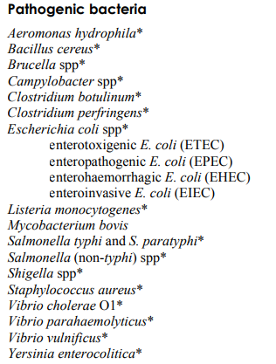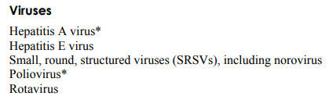

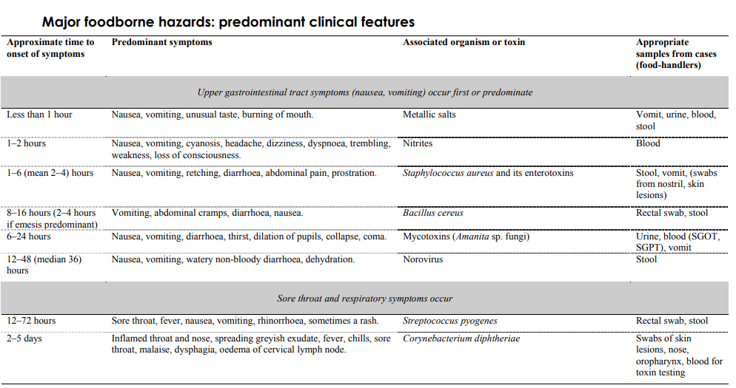

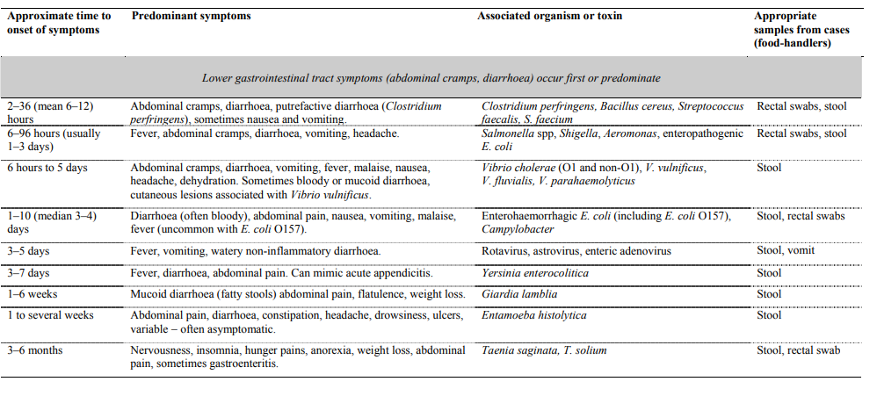
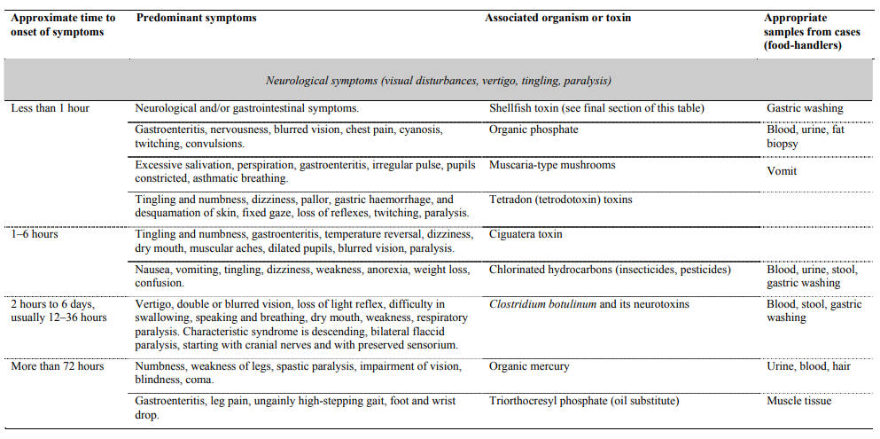
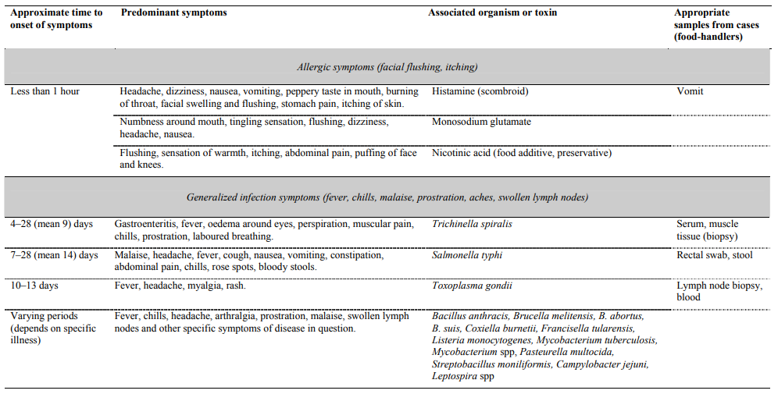
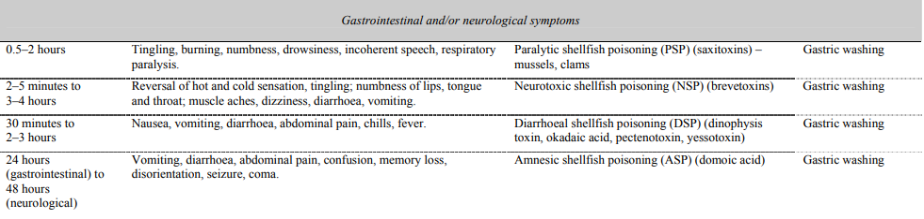
Viruses
Viral gastroenteritis is very common worldwide. There are a number of viruses that are capable of causing foodborne infections, although in most cases, other forms of transmission are more common. Perhaps the best known are noroviruses and hepatitis A, which has been responsible for a number of serious foodborne disease outbreaks, often as a result of poor personal hygiene by infected food handlers.
‘‘New’’ viruses may also pose a threat to food safety. For example, highly pathogenic avian influenza viruses primarily affect birds, but in some cases may be transmitted to humans and cause serious disease. So far, there is no direct evidence that this transmission can be foodborne, but these viruses are a source of great concern to the poultry industry and there is still much to learn about them.

Astroviruses
Astroviruses are spherical, positive-sense, single-stranded RNA viruses belonging to the family Astroviridae. Human astroviruses are classified in the genus Mamastrovirus and at least eight human serotypes (human astrovirus 1 through to human astrovirus 8) have been recognised. Astrovirus infections are mainly spread by person-to-person transmission via the faecal–oral route, however, a very small percentage of infections are estimated to be foodborne (o1%).

Occurrence in Foods
Evidence of astroviruses in naturally grown oysters has been reported in Japan, particularly in product sampled during the winter season.

Effects on Health
Astrovirus infections are associated with watery diarrhoea, nausea, fever, abdominal pain and vomiting. The diarrhoea usually lasts for 2–3 days and is self-limiting, but it can sometimes last as long as 14 days. During infection the virus is excreted in high numbers in the faeces of the affected individual.

Thermal Inactivation
Astroviruses can survive heat treatments of 50 1C for 1 h. A heat process at 60ºC for 15 min is reported to give good reduction in Astrovirus titre value.

Control options
Food handlers should be trained in effective hand-washing techniques and should wash hands after visiting the toilet as well as before handling foods.
Consumers should be educated on the importance of adhering to good personal hygiene during food preparation and should be advised to consume only adequately cooked shellfish, especially oysters, harvested from approved waters.

Hepatitis A virus
The hepatitis A virus (HAV) is an enteric virus, which causes a liver disease in humans now known as hepatitis There are a number of different hepatitis viruses but only the HAV, and possibly the hepatitis E virus, can cause foodborne disease. HAV is a single-stranded RNA virus belonging to the Picornaviridae family and the genus Hepatovirus. Although HAV is most commonly spread by direct person-to-person contact via the faecal–oral route

Occurrence in Foods
The HAV can only be present in foodstuffs as the result of faecal contamination. Although this means that any food that is handled under poor hygienic practices could potentially be contaminated with the pathogen, it is bivalve molluscan shellfish, such as oysters, cockles and mussels, which are most often considered to be a source of foodborne viruses. These shellfish concentrate any virus particles present in their tissues during filter feeding in faecally contaminated water

Effects on Health
The infective dose for the HAV is unknown. However, it is thought that as few as 10–100 virus particles could cause disease. The incubation time for symptoms to appear is on average about 4 weeks, but it can vary from 2–6 weeks. Many cases of HAV infection are asymptomatic, particularly in children. When disease is evident, hepatitis A infection is usually a mild illness. Initial symptoms include headache, fatigue, fever, poor appetite, abdominal discomfort, nausea and vomiting. During infection individuals can excrete high numbers of virus particles (>10⁶ particles/g of faeces).

Thermal Inactivation
The HAV is relatively heat resistant, although thorough cooking at higher temperatures will usually inactivate the virus. It is resistant at 70 ºC for up to 10 min but is inactivated at temperatures of 85 1C for 1 min.

Control options
Strategies to reduce the risk of foodborne outbreaks of hepatitis A should focus on preventing foods from becoming contaminated. In developing countries young children should be kept away from areas where fresh produce is grown and harvested, and clean water should be used for the irrigation, washing and processing of foods. Shellfish-harvesting areas should be monitored for sewage contamination.

Hepatitis E virus (HEV)
The hepatitis E virus (HEV) is an enteric virus, which causes a liver disease in humans now known as hepatitis E (other names for the disease include, enterically transmitted non-A non-B hepatitis and faecal-oral non-A non-B hepatitis). The HEV is distinctly different from the hepatitis A virus and is a single-stranded RNA virus, which has recently been classified in the family Hepeviridae and the genus Hepevirus.

Occurrence in food
The virus is most often associated with pigs, and surveys to determine the frequency of the HEV in pig populations and in pork livers have been conducted in a number of countries. Pigs carrying the HEV do not show any signs of disease and the virus is now known to be present in most pig populations throughout the world.

Effect on health
Although all individuals are susceptible to contracting hepatitis E, the disease is most frequently seen in the 15–40-year-old age group. Many HEV infections are asymptomatic, cause no sign of disease, and where hepatitis E does occur it is usually a mild illness lasting 3–4 weeks. The symptoms for this mild form of the disease include general fatigue, jaundice, production of darker urine and pale stools, abdominal pain, vomiting and nausea. However, the virus can occasionally cause a severe disease with complete liver failure and even death, especially amongst individuals who are pregnant or immunocompromised, suffering from chronic liver disease, or from older age groups. In pregnant women the disease may also cause a miscarriage. In the general population the mortality rate associated with hepatitis E is 0.5–2.0%, but amongst groups susceptible to the more severe form of the disease the fatality rate can be as high as 30%.

Thermal inactivation
It has been concluded that although the HEV is less heat resistant than the hepatitis A virus, some HEV is likely to survive the internal temperatures reached in rare-cooked meat.

Control options
The risk of acquiring hepatitis E through the ingestion of contaminated food is considered low. However, the risk can be reduced further by ensuring that all pork and pork products (including liver) are cooked thoroughly during processing.

Highly pathogenic avian influenza virus

Highly pathogenic avian influenza (HPAI) viruses belong to the family Orthomyxoviridae, and within this family these viruses are in the group known as influenza type-A viruses. Influenza type-A viruses are classified into subtypes, and are named according to two main surface proteins, haemagglutinin (‘‘HA’’) and neuraminidase (‘‘NA’’). To date, 16 HA subtypes, and 9 NA subtypes have been described and many different combinations of HA and NA proteins are known to exist (e.g. H5N1, H1N1, H7N3 and H7N7).
Although influenza A viruses can infect many animals including birds, humans, pigs, dogs, cats and horses, wild birds are the natural hosts for these viruses. Some avian influenza viruses can be transmitted to humans and cause illness. LPAI viruses cause mild symptoms in humans, whereas HPAI can cause severe disease with high mortality rates.

Occurrence in Foods
Poultry, such as chickens and turkeys are particularly susceptible to HPAI viruses such as H5N1. All parts of the infected bird, including blood, meat and bones, are potentially contaminated with virus. The virus is also present in the saliva, nasal excretions and faeces of infected birds resulting in the contamination of feathers. Evidence suggests that the risk of exposure to the H5N1 virus is high during the slaughtering and handling of affected birds, or meat prior to cooking. Uncooked infected chicken carcasses, or possibly infected wild birds consumption causes infection. The HPAI H5N1 virus is also present on the inside and on the surface of eggs laid by infected birds.

Effects on Health
There are many strains of avian influenza A viruses, however, only four subtypes (H5N1, N7N3, H7N7 and H9N2) are known to cause illness in humans. Usually these viruses cause mild influenza-like symptoms such as fever, muscle aches, a cough and a sore throat or sometimes conjunctivitis. Initial effects may include influenza-like symptoms, a temperature of greater than 38ºC, or acute encephalitis. Sometimes, watery diarrhoea without blood, vomiting, chest pain, abdominal pain, and bleeding from the nose and gums.

Thermal Inactivation
HPAI viruses are inactivated when held at 121ºC for 15 min, 60 ºC for 30 min, or at 56 ºC for 3 h. In foods, the H5N1 virus is inactivated when all parts of the item reach 70 ºC or above. Therefore, properly cooked poultry products are safe to eat. The WHO advises that the virus is inactivated during conventional cooking practices used to cook poultry products where temperatures reach 70 ºC or above at the centre of the product.

Control options
Good hygiene practices are essential during slaughter and the post-slaughter handling of poultry carcasses to prevent any possible exposure via raw poultry meat, or cross-contamination from poultry to other foods, food-preparation surfaces, or equipment. Good hygiene is also essential when handling prepared poultry meat and eggs from outbreak areas and thorough cooking of all egg and poultry-meat products should be ensured.

Noroviruses
Noroviruses is the name given to a group of related non-enveloped, single stranded RNA viruses that have recently been classified in the family Caliciviridae, genus Norovirus. These highly infectious enteric viruses are a major cause of acute gastroenteritis in humans (the infection is often called viral gastroenteritis). Although many cases are caused by person-to-person spread, the ingestion of contaminated food or water also plays a significant part in their transmission.

Occurrence in Foods
Food vehicles for noroviruses are thought to include sewage-contaminated bivalve shellfish, foodstuffs that are contaminated by an infected handler, fruits and vegetables contaminated during irrigation or washing, and water
(including drinking water and ice). Infected food handlers can contaminate any foodstuff.

Effects on Health
Noroviruses can cause illness in any age group, although the elderly and the immunocompromised are particularly susceptible. People with blood group O seem more likely to develop a severe infection. Illness can occur at any time of year but in temperate climates is more common during the winter months. Noroviruses are very contagious, however, the illness is usually mild and self-limiting. Signs of infection first appear from between 10–50 h, typically 24–28 h, after ingestion of the virus. The onset of illness is abrupt and typical symptoms are vomiting (often projectile), diarrhoea, abdominal pains, nausea, headache, stomach cramps and occasionally low-grade fever. Recovery is usually complete with no long-lasting effects. During the illness high numbers of the virus are generated in the vomit of affected individuals as well as being shed in their faeces.

Thermal Inactivation
Noroviruses have been shown to remain infective when held at 60ºC for 30 min. It is inactivated by boiling.

Control options
To reduce the risk of food borne transmission of noroviruses, controls should focus on ensuring the use of potable water for food processing, strict hygiene control, and using shellfish from approved waters.

Rotaviruses
Rotaviruses are non-enveloped, double-stranded RNA viruses, which are classified as belonging to the family Reoviridae, genus Rotavirus. There are seven described species or ‘‘serotypes’’ of rotavirus (known by the letters A–G). The name rotavirus is derived from the characteristic wheel like appearance of the viruses when viewed under an electron microscope. Groups A, B and C rotaviruses are known to infect humans, and of these, group A rotaviruses are the most significant. Group A rotaviruses are the leading cause of severe diarrhoea in infants and young children worldwide. Although group A rotaviruses are a major cause of acute diarrhoea it is thought that only a small percentage (around 1%) of cases are actually foodborne, the main route of transmission is person-to-person through the faecal–oral route.

Occurrence in Foods
Potentially, an infected food handler could contaminate any food prepared and consumed without a subsequent heating step. Salads, cold foods (such as sandwiches), fruits and contaminated water (including ice cubes) have all been implicated in cases of foodborne rotavirus infections. Rotaviruses have also been detected in shellfish.

Effects on Health
Disease usually occurs in infants and young children and the most severe symptoms are seen in the very young, the immunocompromised and the elderly. Initial symptoms include vomiting and watery diarrhoea for about 2–3 days, often leading to dehydration. The diarrhoea can sometimes persist for 5–8 days. Without electrolyte replacement and adequate fluids, severe, potentially fatal, dehydration can result. Other symptoms include abdominal discomfort, headaches, chills and low grade fever. In most cases, the infection is self-limiting, and in developed countries most children make a full recovery.

Thermal Inactivation
Rotaviruses are reported to be relatively heat sensitive. Although there is little data on the heat inactivation of these viruses, it is thought that normal cooking processes should inactivate them.

Control Options
Strategies to reduce the risk of food borne outbreaks of rotavirus infections should focus on preventing foods from becoming contaminated by the use of clean water for the irrigation, washing and processing of foods, and preventing shellfish-harvesting areas from becoming contaminated with sewage.

SEA FOOD POSONING

Seafood-related illnesses can be caused by toxins, bacteria, viruses, and parasites. In particular, marine poisoning syndromes are caused by toxins that have accumulated in fish, shellfish, or turtles. Typical food preparation procedures (e.g., cooking, freezing, salting, drying, smoking, or marinating) will not eliminate them.

There are three main types of seafood poisoning:
- ciguatera poisoning
- scombroid, also known as histamine poisoning
- shellfish poisoning

Ciguatera poisoning is a form of food poisoning. It is caused by eating warm water ocean finfish that carry ciguatera poison (a toxin). This poison is produced by a very tiny organism called a dinoflagellate, which attaches itself to algae growing in warm ocean water reef areas. Small plant-eating fish eat these toxic algae and in turn are eaten by larger predatory fish which are eaten by humans. Fish that feed in warm ocean waters are potential carriers of ciguatera toxin.

Scombroid fish poisoning results from eating fish with high levels of histamine. Histamine is produced by bacteria in fish. When fish are not quickly chilled after capture, or have not been stored at correct temperature prior to consumption, the bacteria can multiply and produce high amounts of histamine. It can occur in many species of fish, including skipjack, mackerel, tuna, sardines, anchovy, marlin, and bonito.

Shellfish can carry a variety of naturally occurring seafood toxins that cause poisoning in humans including: paralytic shellfish poisoning, amnesic shellfish poisoning, neurotoxic shellfish poisoning and diarrhoetic shellfish poisoning.

Ciguatera poisoning:
The symptoms of ciguatera poisoning start between 1 and 24 hours after eating a toxic fish and include:
- tingling and numbness in fingers, toes, around lips, tongue, mouth and throat
- burning sensation or pain on contact with cold water
- joint and muscle pains with muscular weakness
- nausea, vomiting, diarrhoea and/or abdominal cramps
- headache, fatigue and fainting
- extreme itchiness, often worsened by drinking alcohol
- difficulty in breathing in severe cases.

Scombroid fish poisoning occurs very quickly after eating the fish, usually within 30 minutes, but may be up to several hours later. Common symptoms include:
- a peppery or metallic taste
- flushing of the upper body,
- itching
- headache and dizziness
- vomiting, diarrhoea and abdominal cramps
In severe cases difficulty with breathing and low blood pressure may occur.
Shell fish poisoning:
Paralytic shellfish poisoning – a very serious, potentially fatal disease affecting the nervous system. Symptoms can occur within half an hour to two hours after consuming the affected shellfish and include numbness and tingling of the lips and extremities and gastrointestinal symptoms.
Amnesic shellfish poisoning – another serious illness that can potentially cause death or coma. It affects the nervous system and the gut and symptoms usually appear within a day of eating the affected shellfish.
Neurotoxic shellfish poisoning – has symptoms similar to ciguatera poisoning (see above) but less severe, usually only lasting a few days.
Diarrhoetic shellfish poisoning – symptoms including diarrhoea and vomiting, usually appear approximately half an hour after consuming affected fish but lasts only a few days.

Human shell fish poisoning
Human shellfish poisoning can occur after eating clams, mussels, oysters, scallops, cockles, starfish, and crustaceans contaminated by toxins. Herbivorous dinoflagellates are the primary transvectors that accumulate the toxins via feeding in their digestive organs and soft tissues, apparently without harm to themselves. Shellfish consume dinoflagellate organisms while feeding, and the poison is stored in their bodies. This toxin has been found in these sea foods every month of the year, and butter clams have been known to store the toxin for up to 2 years. Shellfish poisoning is more common during red tides, when sea waters turn a reddish color because of the presence of large numbers of dinoflagellates. These dinoflagellates produce at least 12 toxins, which are tetrahydropurines and are heat and acid stable. Saxitoxin was the first characterized and the best understood, and it produces paralysis. Humans, birds, and fish can all be affected by paralytic shellfish poisoning toxins. Shellfish contaminated by toxins do not have an abnormal taste, smell, or color; the toxins are water soluble and are not destroyed by acid, heating, or cooking. Shellfish poisoning can produce four clinical syndromes—paralytic shellfish poisoning, neurotoxic shellfish poisoning, diarrheal shellfish poisoning, and amnesic shellfish poisoning.

The main toxins responsible for each of the shellfish syndromes are as follows:
Paralytic shellfish poisoning—saxitoxin
Neurotoxic shellfish poisoning—brevetoxin
Diarrheal shellfish poisoning—okadaic acid
Amnesic shellfish poisoning—domoic acid

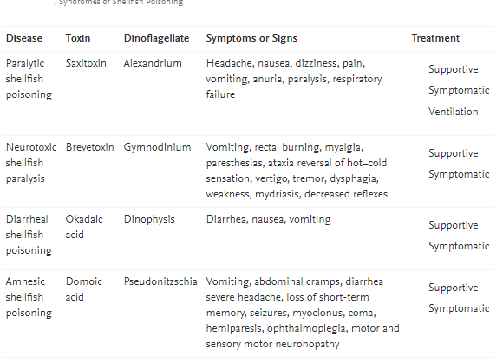

MYCOTOXINS
- Mycotoxins are naturally occurring toxins produced by certain moulds (fungi) and can be found in food.
- The moulds grow on a variety of different crops and foodstuffs including cereals, nuts, spices, dried fruits, apples and coffee beans, often under warm and humid conditions.
- Mycotoxins can cause a variety of adverse health effects and pose a serious health threat to both humans and livestock.
- The adverse health effects of mycotoxins range from acute poisoning to long-term effects such as immune deficiency and cancer.
- A scientific expert committee jointly convened by WHO and the Food and Agriculture Organization of the United Nations (FAO) – called JECFA – is the international body responsible for evaluating the health risk from natural toxins including mycotoxins.
- International standards and codes of practice to limit exposure to mycotoxins from certain foods are established by the Codex Alimentarius Commission based on JECFA assessments.

Introduction: Mycotoxins are toxic compounds that are naturally produced by certain types of moulds (fungi). Moulds that can produce mycotoxins grow on numerous foodstuffs such as cereals, dried fruits, nuts and spices. Mould growth can occur either before harvest or after harvest, during storage, on/in the food itself often under warm, damp and humid conditions. Most mycotoxins are chemically stable and survive food processing.
Several hundred different mycotoxins have been identified, but the most commonly observed mycotoxins that present a concern to human health and livestock include aflatoxins, ochratoxin A, patulin, fumonisins, zearalenone and nivalenol/deoxynivalenol. Mycotoxins appear in the food chain as a result of mould infection of crops both before and after harvest. Exposure to mycotoxins can happen either directly by eating infected food or indirectly from animals that are fed contaminated feed, in particular from milk.

Mycotoxins commonly found in food and concern
The effects of some food-borne mycotoxins are acute with symptoms of severe illness appearing quickly after consumption of food products contaminated with mycotoxins. Other mycotoxins occurring in food have been linked to long-term effects on health, including the induction of cancers and immune deficiency. Of the several hundred mycotoxins identified so far, about a dozen have gained the most attention due to their severe effects on human health and their occurrences in food.
Aflatoxins are amongst the most poisonous mycotoxins and are produced by certain moulds (Aspergillus flavus and Aspergillus parasiticus) which grow in soil, decaying vegetation, hay, and grains. Crops that are frequently affected by Aspergillus spp. include cereals (corn, sorghum, wheat and rice), oilseeds (soybean, peanut, sunflower and cotton seeds), spices (chili peppers, black pepper, coriander, turmeric and ginger) and tree nuts (pistachio, almond, walnut, coconut and Brazil nut). The toxins can also be found in the milk of animals that are fed contaminated feed, in the form of aflatoxin M1. Large doses of aflatoxins can lead to acute poisoning (aflatoxicosis) and can be life threatening, usually through damage to the liver. Aflatoxins have also been shown to be genotoxic, meaning they can damage DNA and cause cancer in animal species. There is also evidence that they can cause liver cancer in humans.
Ochratoxin A is produced by several species of Aspergillus and Penicillium and is a common food-contaminating mycotoxin. Contamination of food commodities, such as cereals and cereal products, coffee beans, dry vine fruits, wine and grape juice, spices and liquorice, occurs worldwide. Ochratoxin A is formed during the storage of crops and is known to cause a number of toxic effects in animal species. The most sensitive and notable effect is kidney damage, but the toxin may also have effects on fetal development and on the immune system. Contrary to the clear evidence of kidney toxicity and kidney cancer due to ochratoxin A exposure in animals, this association in humans is unclear, however effects on kidney have been demonstrated.
Patulin is a mycotoxin produced by a variety of moulds, like Aspergillus, Penicillium and Byssochlamys. Often found in rotting apples and apple products, patulin can also occur in various mouldy fruits, grains and other foods. Major human dietary sources of patulin are apples and apple juice made from affected fruit. The acute symptoms in animals include liver, spleen and kidney damage and toxicity to the immune system. For humans, nausea, gastrointestinal disturbances and vomiting have been reported. Patulin is considered to be genotoxic however a carcinogenic potential has not been demonstrated yet.
Fusarium fungi are common to the soil and produce a range of different toxins, including trichothecenes such as deoxynivalenol (DON), nivalenol (NIV) and T-2 and HT-2 toxins, as well as zearalenone (ZEN) and fumonisins. The formation of the moulds and toxins occur on a variety of different cereal crops. Different fusarium toxins are associated with certain types of cereal. For example, both DON and ZEN are often associated with wheat, T-2 and HT-2 toxins with oats, and fumonisins with maize (corn). Trichothecenes can be acutely toxic to humans, causing rapid irritation to the skin or intestinal mucosa and lead to diarrhoea. Reported chronic effects in animals include suppression of the immune system. ZEN has been shown to have hormonal, estrogenic effects and can cause infertility at high intake levels, particularly in pigs. Fumonisins have been related to oesophageal cancer in humans, and to liver and kidney toxicity in animals.

Minimising risk of mycotoxins
It is important to note that mould that produces mycotoxins can grow on a variety of different crops and foodstuff and can penetrate deep into food and do not just grow on the surface. Mould usually does not grow in properly dried and stored foods, so efficient drying of commodities and maintenance of the dry state, or proper storage, is an effective measure against mould growth and the production of mycotoxins.
To minimize the health risk from mycotoxins, people are advised to:
- inspect whole grains (especially corn, sorghum, wheat, rice), dried figs and nuts such as peanuts, pistachio, almond, walnut, coconut, Brazil nuts and hazelnuts which are all regularly contaminated with aflatoxins for evidence of mould, and discard any that look mouldy, discoloured, or shrivelled;
- avoid damage of grains before and during drying, and in storage, as damaged grain is more prone to invasion of moulds and therefore mycotoxin contamination;
- buy grains and nuts as fresh as possible;
- make sure that foods are stored properly – kept free of insects, dry, and not too warm;
- not keep foods for extended periods of time before being used; and
- ensure a diverse diet – this not only helps to reduce mycotoxins exposure, but also improves nutrition.
- Viral gastroenteritis is very common worldwide. There are a number of viruses
- that are capable of causing foodborne infections, although in most cases, other
- forms of transmission are more common. Perhaps the best known are noroviruses
- and hepatitis A, which has been responsible for a number of serious
- foodborne disease outbreaks, often as a result of poor personal hygiene by
- infected food handlers.
- ‘‘New’’ viruses may also pose a threat to food safety. For example, highly
- pathogenic avian influenza viruses primarily affect birds, but in some cases may
- be transmitted to humans and cause serious disease. So far, there is no direct
- evidence that this transmission can be foodborne, but these viruses are a source of
- great concern to the poultry industry and there is still much to learn about them.

